


American International University-Bangladesh
Dhaka — 1229, Bangladesh

Department of Computer Science

Course Code: CSC2108 Course Title: Introduction to Database
Section: [I]

Database final Project: University management system

Instructed by:
MD. Ariful Islam
Lecturer, Faculty of Science and Technology American International University-Bangladesh

Date of Submission: August 13, 2023

TABLE OF CONTENTS

TOPICS Page No.

- Title Page 2
- Table of Content 3
  - Introduction 3
  - Case Study 4
  - ER Diagram 5
  - Normalization 4
  - Finalization 17
  - Description Of Table creations 19
  - Tables Data 29
  - Query 38
  - Conclusion 47

Introduction

The digital revolution has reshaped how we manage the data of a university, ushering in the era of online management system. Embracing this shift, The University Management System introduces an advanced platform that effortlessly weaves together employee, student, professor, and other data. The following system helps the user to find out the specific data. It’s like a helpful guide for exploring and utilizing data.
The purpose of this project is to design and implement a university database management system that can store and manage information about employees, students, professor and other relevant data. the system is designed to support a small-scale university with the potential for scalability in the future.

CASE STUDY

In a university management system, an employee is identified by a employee id. The system also stores employee name, DOB, salary, address, position and phone number. Employee name is composed of first name and last name. faculty is an employee. Faculties have an unique employee id. Each faculty also has their name, dob, salary, address, department and phone number. Address consists of city and postal code. Many faculty might manage one department. Each department has its name and a unique id stored in the database. A student is identified by an student id . Student name, address, phone number, program, enroll date, DOB and CGPA are also stored in database. Student names are composed of first name and last name. A student is taught by many faculty. A faculty may teach many students. There might be many courses in one semester. Courses are identified by a course id. Name and credits of each course are also stored in the database. Many faculties may take many courses. A course is identified by a course id. Course name and course credit are stored in database . A student can enroll in only one semester at time.A semester is identified by a semester id. Startdate, enddate and semester name are stored in database.

ER Diagram

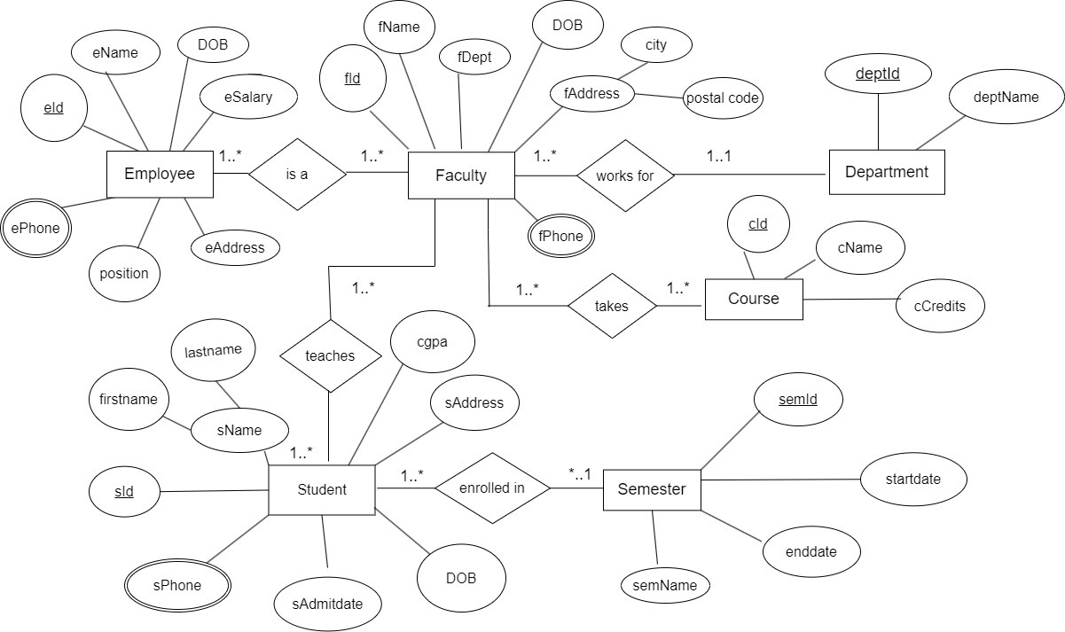

NORMALIZATION

- is a (Many to many):

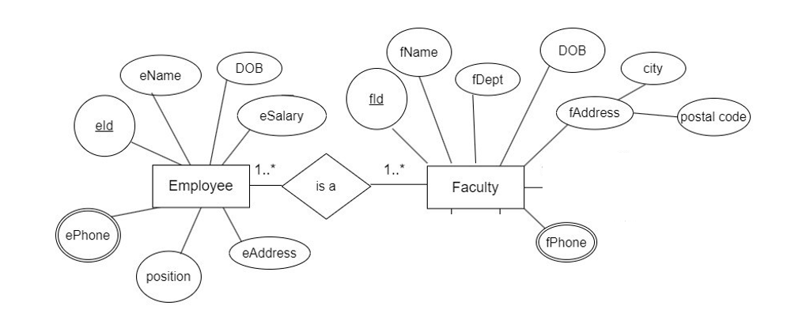

UNF: eId, eName, DOB, eSalary, eAddress, position, ePhone, fId, fName,fDept, DOB, fAddress,city, postal code, fPhone.

1NF: eId, eName, DOB, eSalary, eAddress, ePhone, fId, fName, fDept, DOB, fAddress, city, postal code, fPhone.
2NF:
- eId(pk), eName, DOB, eSalary, eAddress, position, ePhone
- fId(pk), fName, fDept, DOB, fAddress, city, postal code, fPhone.
- eId(pk),fId(fk).
3NF:
1. eId(pk), eName, DOB, eSalary, eAddress, position, ePhone.
2. fId(pk), fName, fDept, DOB, fAddress, city, fPhone.
3.eId(pk), fId(fk).

Works for (many to one):

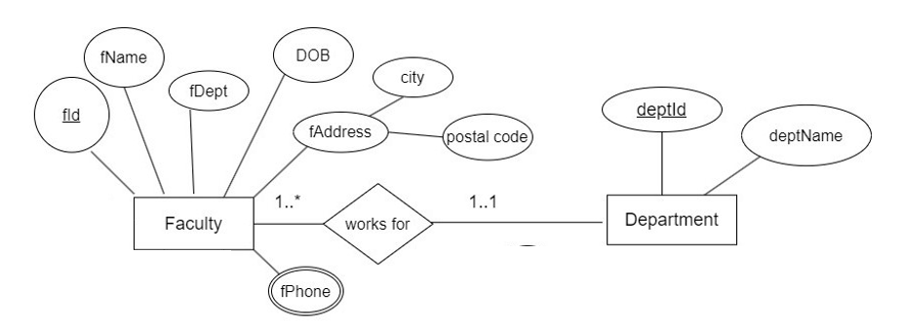

UNF: fId, fName, fDept, DOB, fAddress, city, postal code, fPhone, deptId, deptName.

1NF: fId, fName, fDept, DOB, fAddress, city, postal code, fPhone, deptId, deptName.

2NF:
- fId(pk), fName, fDept, DOB, fAddress, city, postal code, fPhone.
- deptId(pk), deptName.
- fId(pk), deptId(fk).

3NF:
- fId(pk), fName, fDept, DOB, fAddress, city, fPhone.
- deptId(pk), deptName.
- fId(pk), deptId(fk).

3. takes (Many to many):

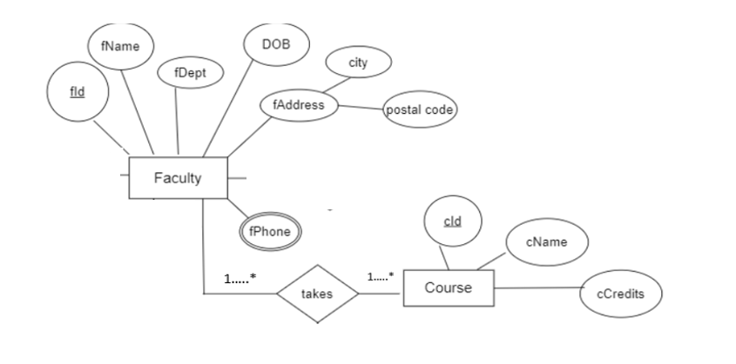

- UNF: fId, fName, fDept, DOB, fAddress, city, postal code, fPhone, cId, cName, cCredit.
- 1NF: fId, fName, fDept, DOB, fAddress, city, postal code, fPhone, cId, cName, cCredit.

2NF:

- fId(pk), fName, fDept, DOB, fAddress, city, postal code, fPhone.
- cId(pk), cName, cCredit.
- fId(pk),cId(fk).

3NF:
1.fId(pk), fName, fDept, DOB, fAddress, city, fPhone.
2. cId(pk), cName, cCredit.
3. fId(pk),cId(fk).

- teaches (Many to many):
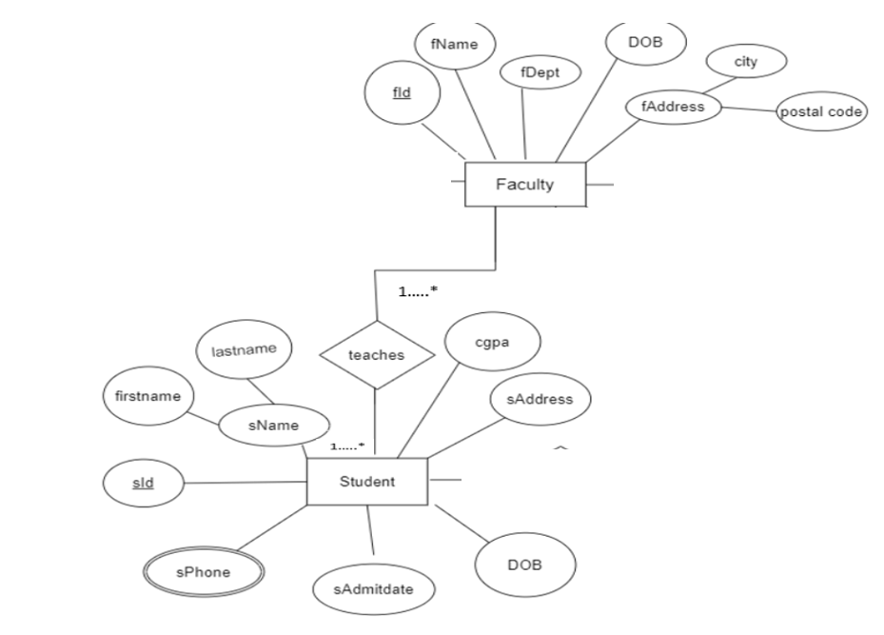

UNF: fId, fName, fDept, DOB, fAddress, city, postal code, fPhone, sId, sName, firstname, lastname, cgpa, sAddress, DOB, sAdmitdate, sPhone.
1NF: fId, fName, fDept, DOB,fAddress, city, postal code, fPhone, sId, sName, firstname, lastname, cgpa, sAddress, DOB, sAdmitdate, sPhone.
2NF:
- fId(pk), fName, fDept, DOB, fAddress, city, postal code, fPhone.
- sId(pk), sName, firstname, lastname, cgpa, sAddress, DOB, sAdmitdate, sPhone.
- fId(pk),sId(fk).
3NF:
1. fId(pk), fName,fDept, DOB, fAddress, city, postal code, fPhone.
2. sId(pk), sName, firstname, cgpa, sAddress, DOB, sAdmitdate, sPhone.
3. fId(pk),sId(fk).

enrolled in (Many to one):

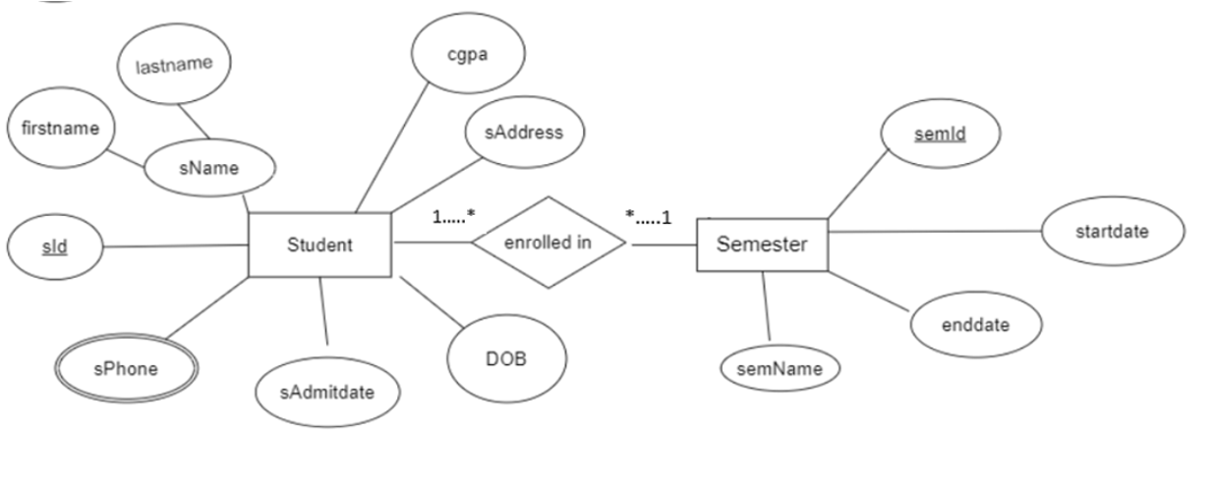

UNF: sId, sName, firstname, lastname, cgpa, sAddress, DOB, sAdmitdate, sPhone, semId, startdate, enddate, semName

1NF: sId, sName, firstname, lastname, cgpa, sAddress, DOB, sAdmitdate, sphone, semId, startdate, enddate, semName.
2NF:
1) sId(pk), sName, firstname, lastname, cgpa, sAddress, DOB, sAdmitdate, sPhone
2) semId(pk), startdate, enddate, semName
3)sId(pk), semId(fk)

3NF:
1) sId(pk), sName, firstname, cgpa, sAddress, DOB, sAdmitdate, sPhone
2) semId(pk), startdate, enddate, semName
3)sId(pk), semId(fk).

FINALIZATION
1. eId(pk), eName, DOB, eSalary, eAddress, position, ePhone. (Employee)
2. fId(pk), fName, fDept, DOB, fAddress, city, fPhone. (Faculty)
3. eId(pk), fId(fk).
4. fId(pk), fName, fDept, DOB, fAddress, city, fPhone. (Faculty)
5. deptId(pk), deptName. (Depertment)
6. fId(pk), deptId(fk).
7. fId(pk), fName, fDept, DOB, fAddress, city, fPhone. (Faculty)
8. cId(pk), cName, cCredit. (Course)
9. fId(pk),cId(fk).
10. fId(pk), fName, fDept, DOB, fAddress, city, postal code, fPhone. (Faculty)
11. sId(pk), sName, firstname, cgpa, sAddress, DOB, sAdmitdate, sPhone. (Student)
12. fId(pk), sId(fk).
13. sId(pk), sName, firstname, cgpa, sAddress, DOB, sAdmitdate, sPhone (Student)
14. semId(pk), startdate, enddate, semName. (Semester)
15. sId(pk), semId(fk).

6. TABLE CREATION
Table creation command and description of the Employee Table: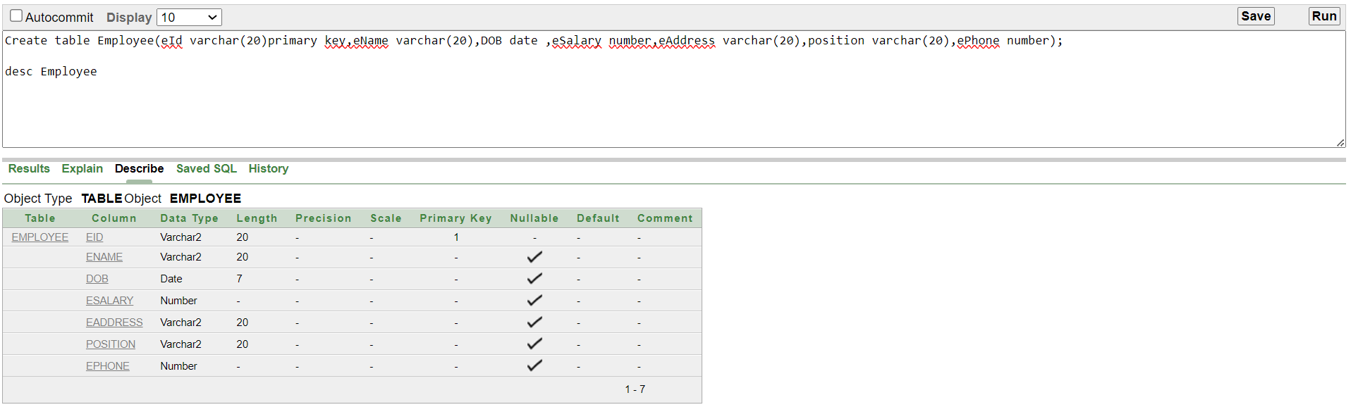

Create table Employee(eId varchar(20)primary key,eName varchar(20),DOB date ,eSalary number,eAddress varchar(20),position varchar(20),ePhone number);

Table creation command and description of the Faculty Table:
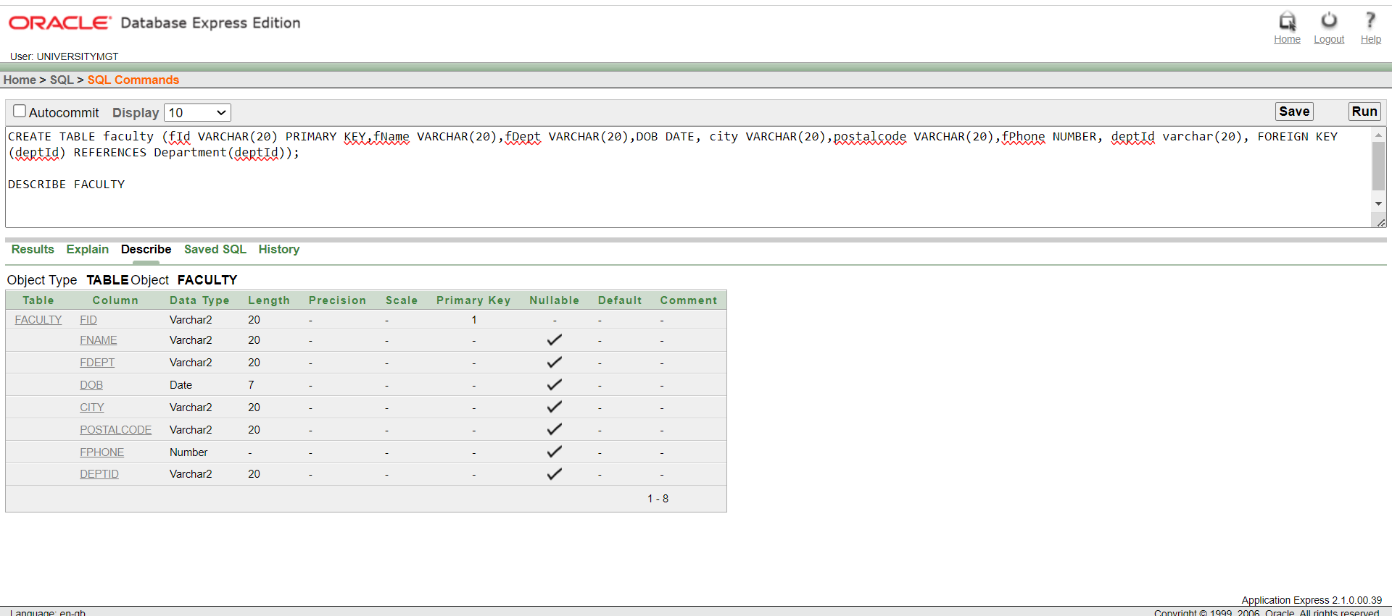
CREATE TABLE faculty (fId VARCHAR(20) PRIMARY KEY,fName VARCHAR(20),fDept VARCHAR(20),DOB DATE, city VARCHAR(20),postalcode VARCHAR(20),fPhone NUMBER, deptId varchar(20), FOREIGN KEY (deptId) REFERENCES Department(deptId));
Table creation command and description of the Department Table: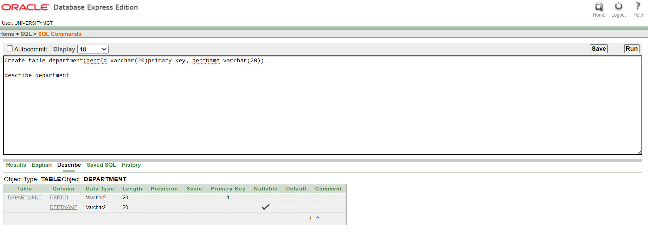
Create table department(deptId varchar(20)primary key, deptName varchar(20))

Table creation command and description of the Course Table: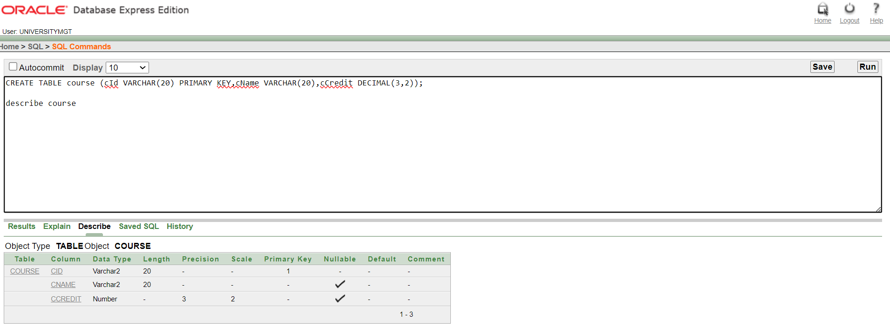
CREATE TABLE course (cId VARCHAR(20) PRIMARY KEY,cName VARCHAR(20),cCredit DECIMAL(3,2));

Table creation command and description of the Student Table: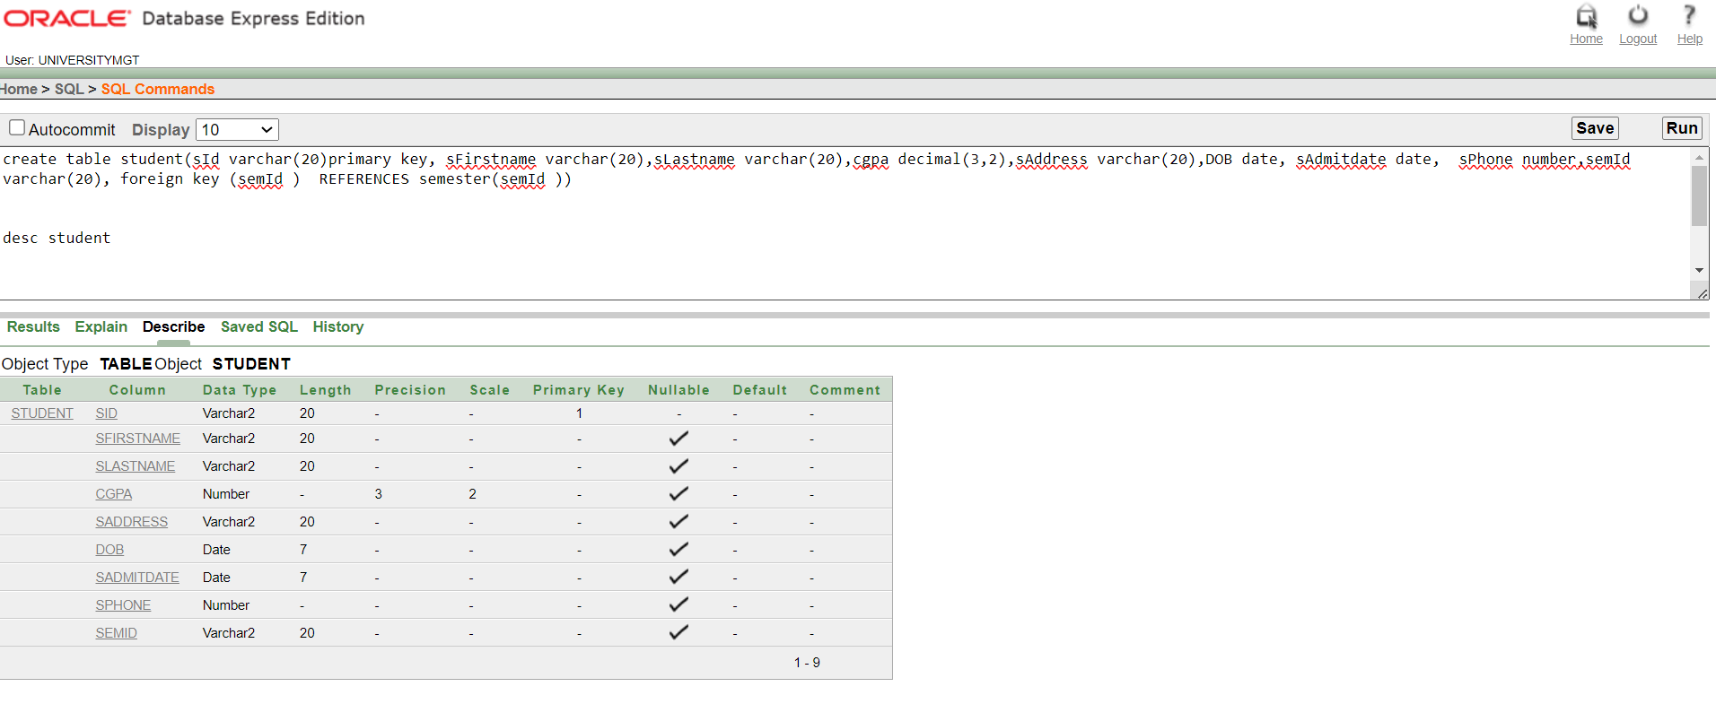
create table student(sId varchar(20)primary key, sFirstname varchar(20),sLastname varchar(20),cgpa decimal(3,2),sAddress varchar(20),DOB date, sAdmitdate date, sPhone number,semId varchar(20), foreign key (semId ) REFERENCES semester(semId ))

Table creation command and description of the Semester Table: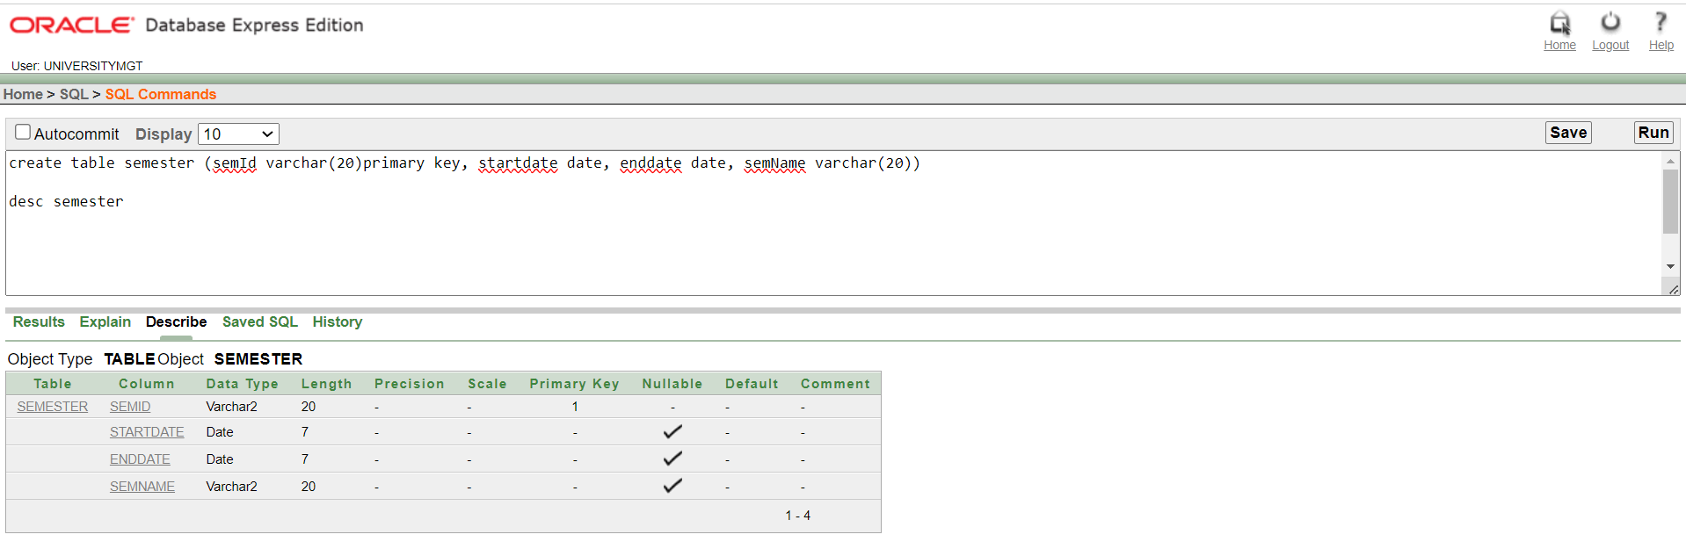
create table semester (semId varchar(20)primary key, startdate date, enddate date, semName varchar(20))
INSERT INTO semester VALUES ('F2023', TO_DATE('17-09-2023', 'DD-MM-YYYY'), TO_DATE('31-12-2023', 'DD-MM-YYYY'), 'fall');

7. INSERTION
Value insertion in Employee table:
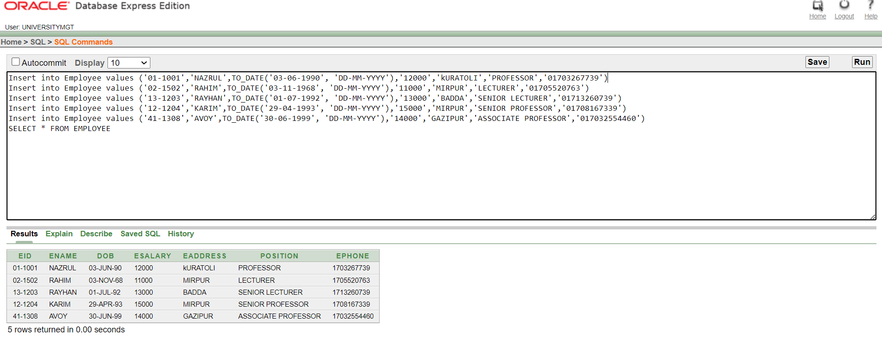

Value insertion in Faculty table: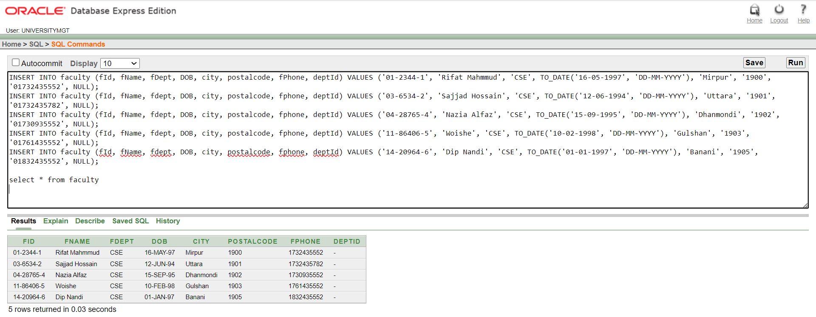

Value insertion in Department table: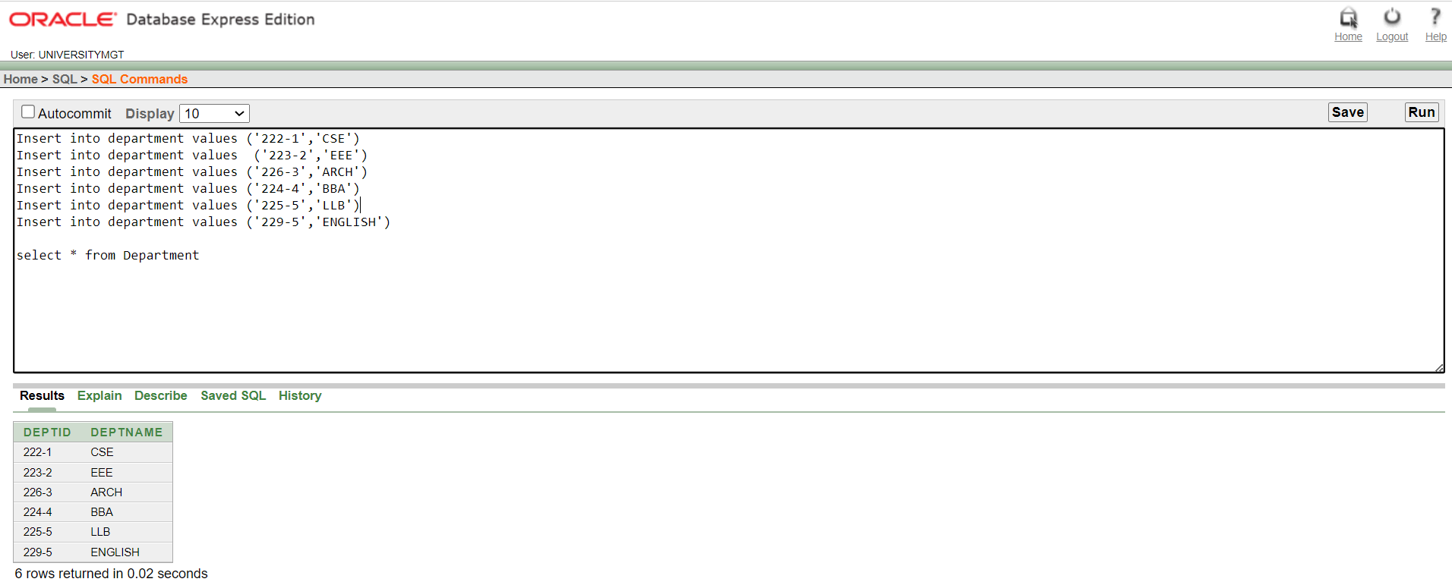

Value insertion in Course table: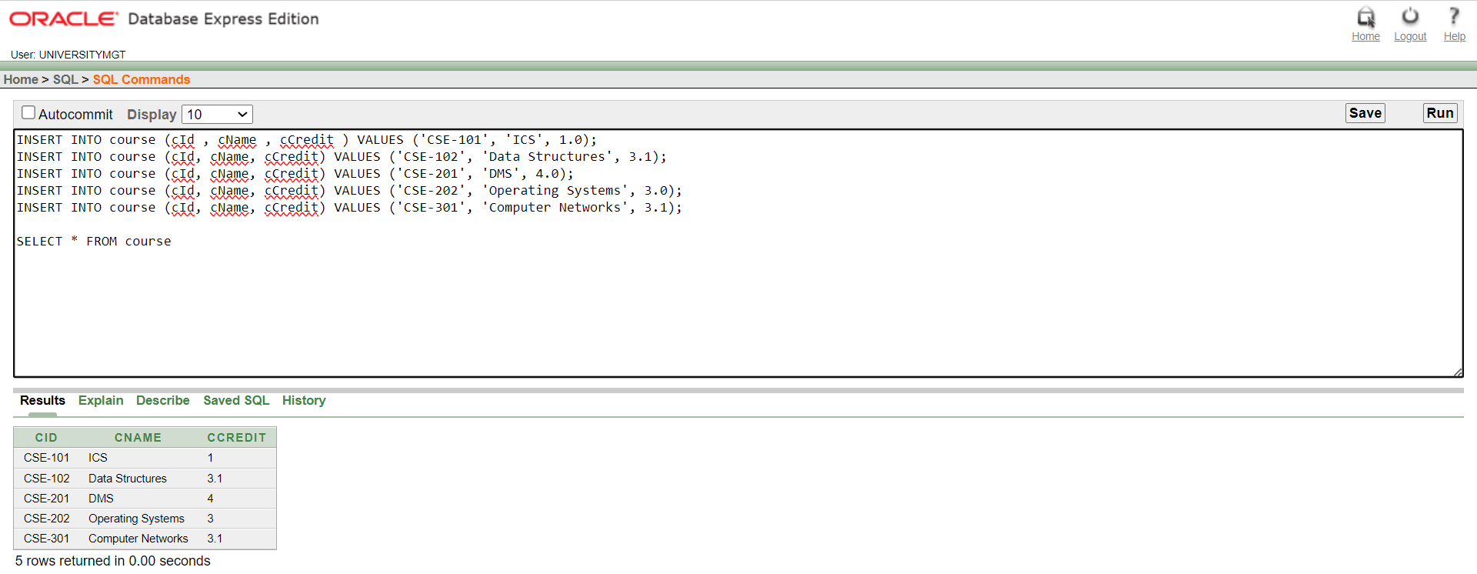
Value insertion in Student table: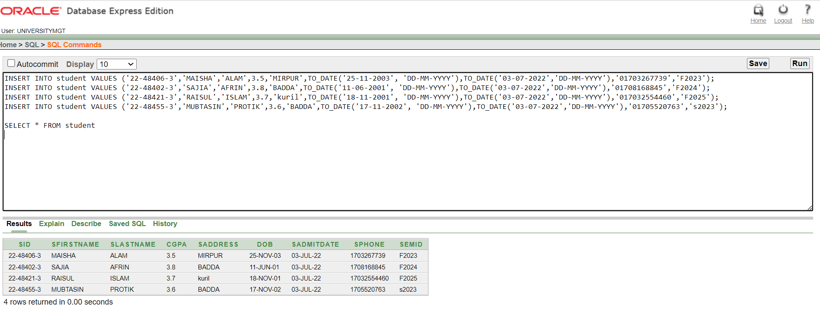

Value insertion in Semester table: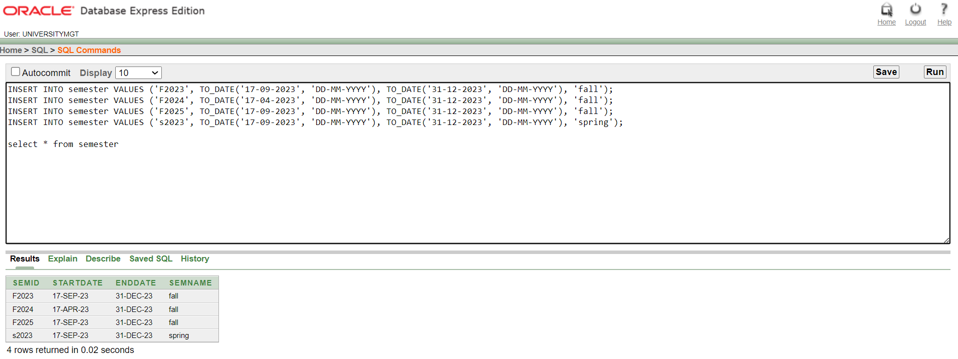

8. QUERY WRITING
Simple query
1.Show all from student where the student's first letter starts with 'M'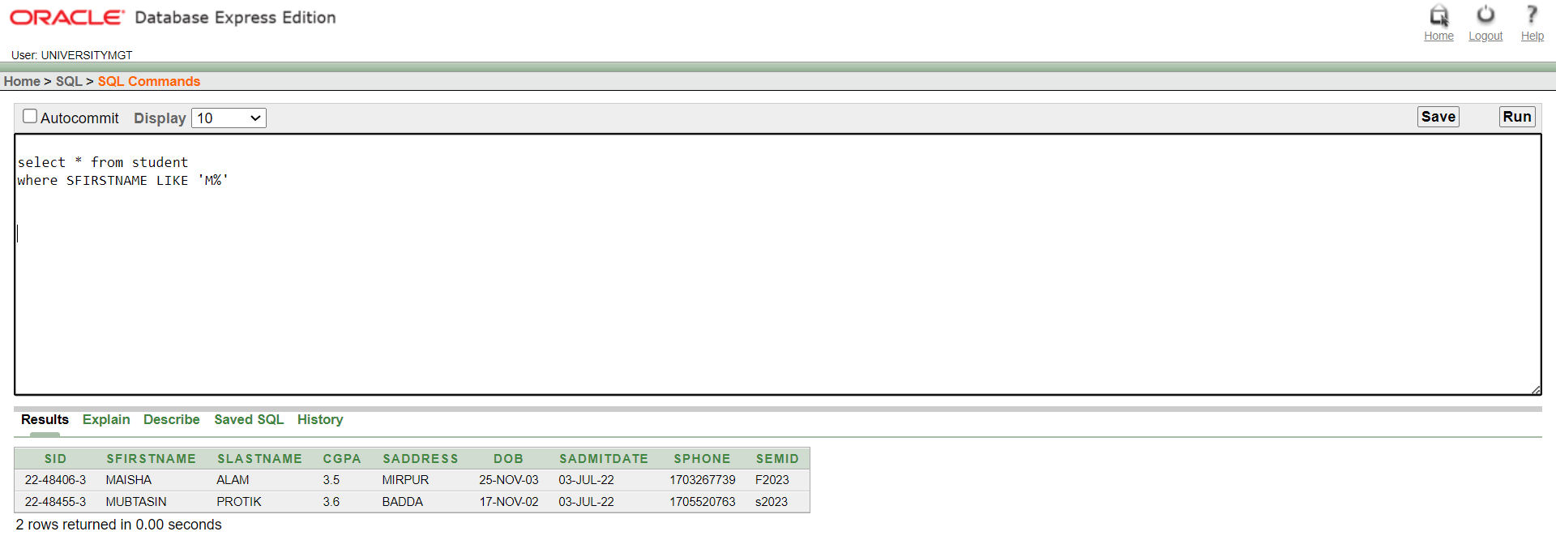

Single row function:
2.Show how old is each employee as of today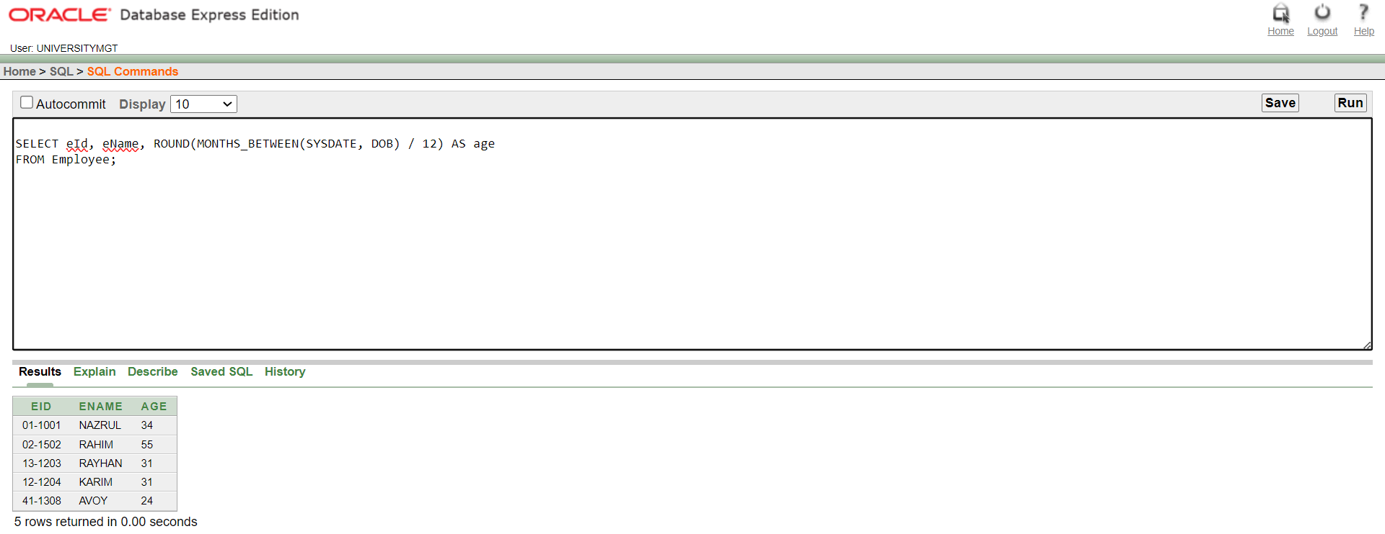

Multiple row function:
3.Show the average CGPA of the students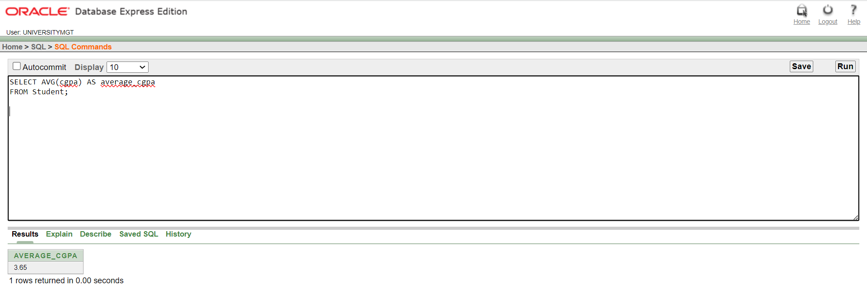

Single row subquery:
4. Show all information from employee who has maximum salary.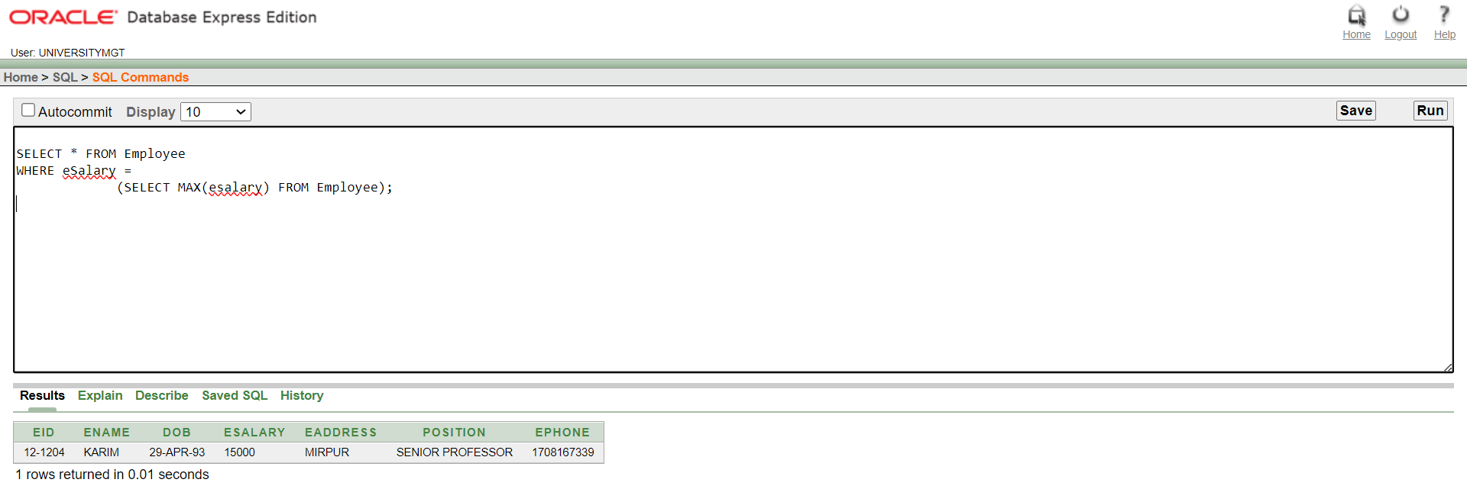

Multiple row subquery:
5. Display the employees who are earning more than NAZRUL.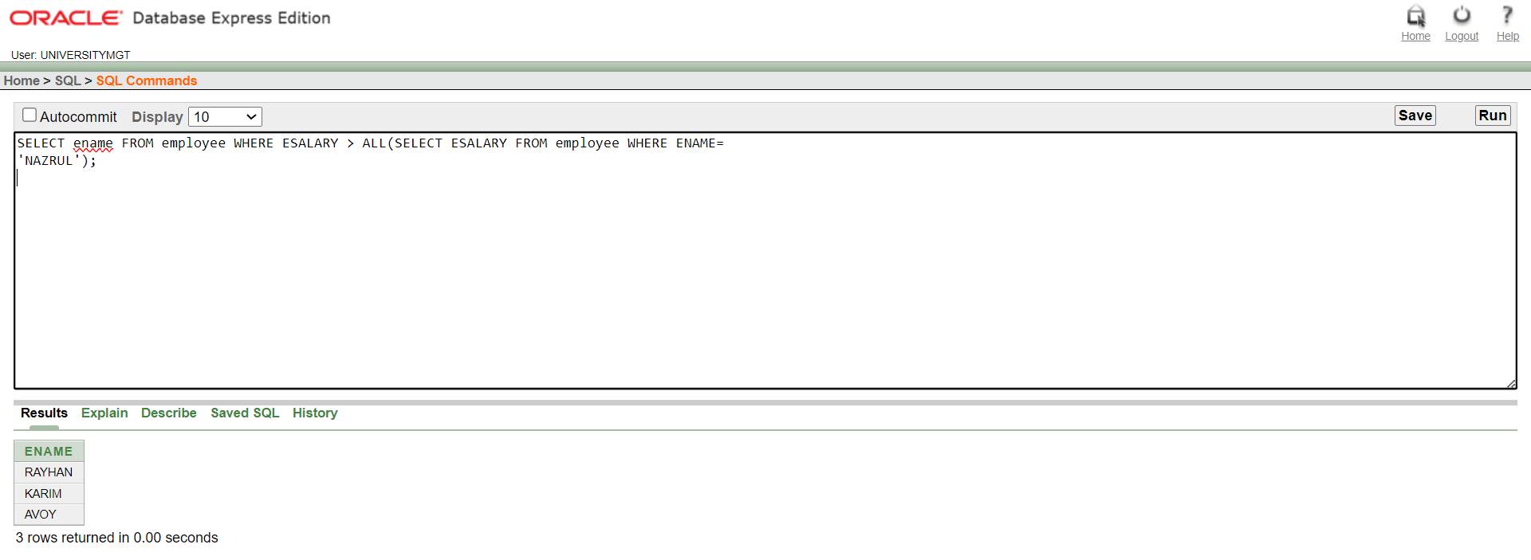

Equijoin:
6. Display the list of students and semester who share the same id, along with their names, addresses, and semester positions?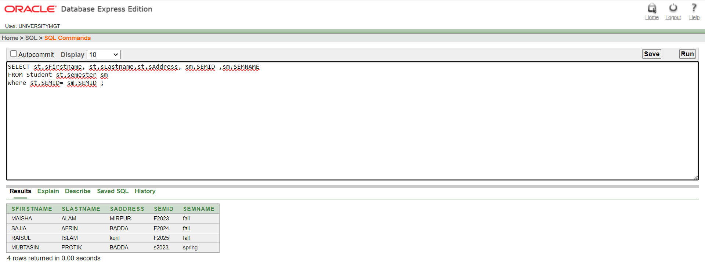

Selfjoin:
7. Write a query to show “sname lives in saddress” with self join putting sname
and saddress in different object aliases and saddress being the identitcal column between them.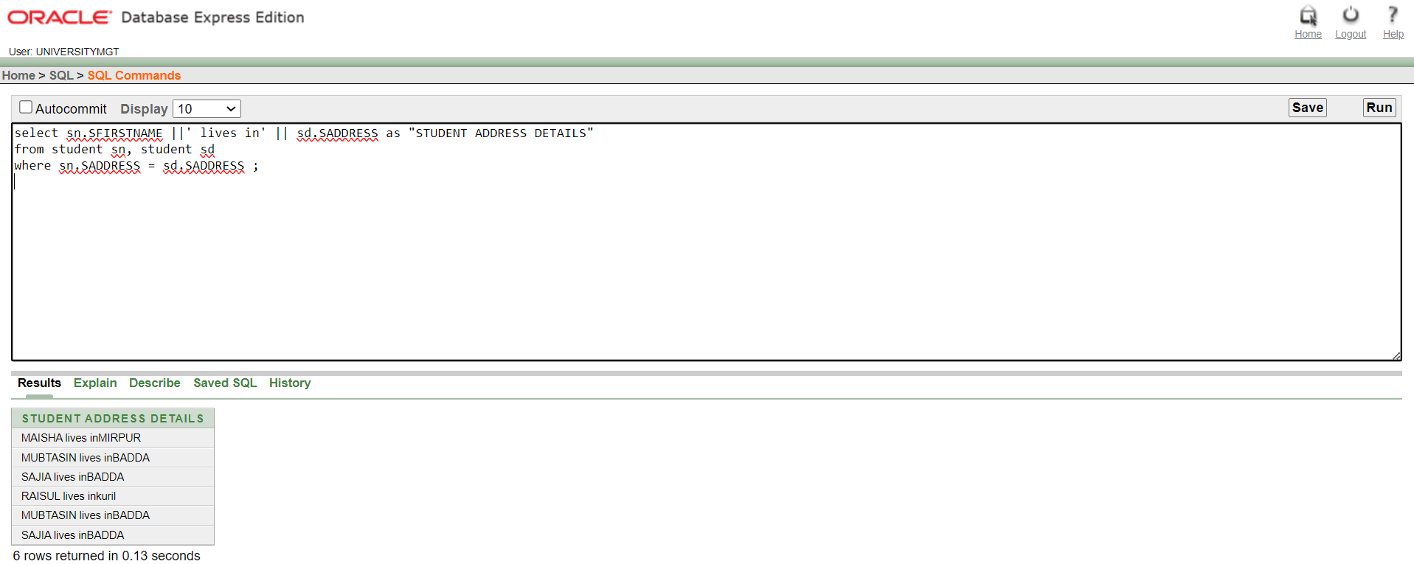

Simple view:
8. How many students are there from each address?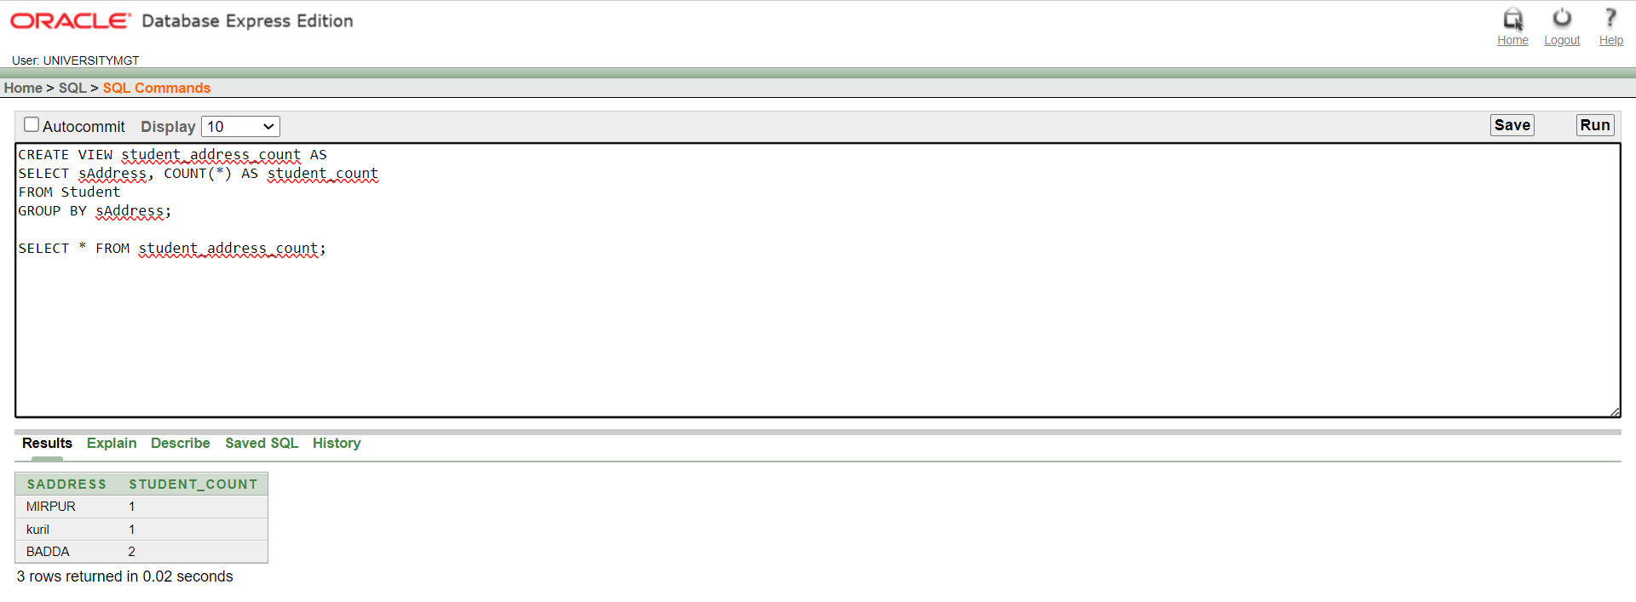

Complex view:
9. Create a complex view which contains sFirstname, sLastname, sAddress, SEMNAME, SEMID from
table Student and semester where SEMID column matches between the two table